CCJK Technologies

🔹 Definition
# Source: ScreenShots Source: Provided by: [Persons Table -> ID Column: 1, Name_En Column: Motasem Essam] -> Tool: [Lightshot Program] -> From [Site: https://www.ccjk.com/] on [11/13/2025]
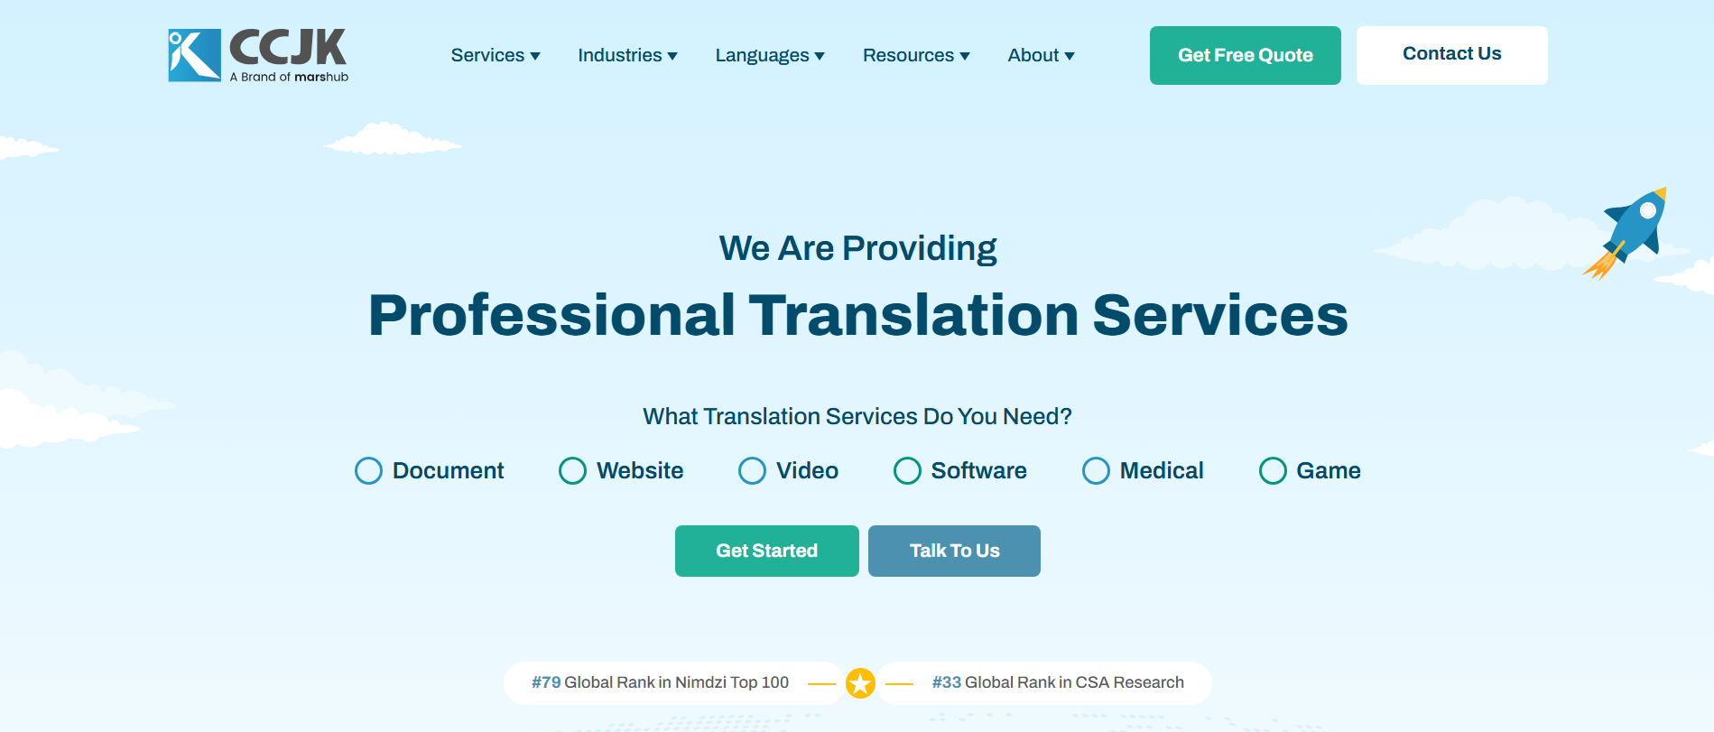
# Source: AI Source: Provided by: [Data Path: Persons Table -> ID Column: 1, Name_En Column: Motasem Essam] -> From: [ChatGPT] on [11/13/2025]
CCJK Technologies is a global language service provider specializing in translation, localization, interpretation, and multilingual content services. It helps businesses and organizations adapt their content, products, and communications for different languages and cultural markets.
Here’s a detailed breakdown:

🔹 Key Facts About CCJK
# Source: AI Source: Provided by: [Data Path: Persons Table -> ID Column: 1, Name_En Column: Motasem Essam] -> From: [ChatGPT] on [11/13/2025]
- Founded: Over 20 years ago (exact founding date varies by source)
- Headquarters: China (with a global client base)
- Services Offered:
  - Translation: Written content across 230+ languages
  - Localization: Adapting websites, software, apps, and multimedia for local markets
  - Interpretation: Simultaneous and consecutive interpretation for events and meetings
  - Multilingual Content Services: Subtitling, voiceovers, desktop publishing, and transcription
- Industries Served: IT, healthcare, legal, gaming, marketing, finance, and more

🔹 Why It Matters
# Source: AI Source: Provided by: [Data Path: Persons Table -> ID Column: 1, Name_En Column: Motasem Essam] -> From: [ChatGPT] on [11/13/2025]
- CCJK ensures that businesses communicate effectively across different languages and cultures.
- Their services go beyond literal translation—they localize content to fit cultural, legal, and contextual norms in target markets.
- They are ISO-certified, which guarantees quality and reliability in professional language services.

🔹 Audience / Users
# Source: AI Source: Provided by: [Data Path: Persons Table -> ID Column: 1, Name_En Column: Motasem Essam] -> From: [ChatGPT] on [11/13/2025]
- Global companies entering new markets
- Software and app developers needing localization
- Legal and healthcare organizations requiring precise translations
- Marketing and media teams creating multilingual campaigns

In short: CCJK is a professional partner for businesses seeking multilingual communication and localization services worldwide.

